2019 East Asian International Dance Competition Application form

※ Marked by ∨ check in that category
※ If you are a group / duet participant, please fill out only 2 representative pages.

Participation | □Ballet (□ Classic □ Creation) □Contemporary □Practical Dance |  |  |  |  |  |  | Photo  ( 4 X 6 )
 | Practical | □Street1 □Jazz  □Street2 □ Practical |  |  |  | Part
□PreYoung □PreJuniorⅠ □PreJuniorⅡ □Junior
□Senior □SeniorⅠ □SeniorⅡ
 | □Solo □Duet □Group (Individual application form on page 2)
Sex | □Male □Female |  |  |  | Age |  | Age
Name
Address | Zip Code
Information | Phone |  |  |  | E-mail
 | Nationality |  |  |  | Passport
School /Group | Pertain |  | School / Academy
 | Phone
 | Address
Chieftain (Choreographer) Information
Name |  |  |  |  |  |  |  | Photo  ( 4 X 6 )
Information | Nationality |  |  |  | E-mail
 | Phone |  |  |  | Pertain

Individual application for group participants
※ If you do not have enough input, you can copy and use the form.
Number | Participant information (individual participation except representative)
1 | Name
 | Information | Nationality |  | E-mail
 |  | Sex | □Male □Female | Pertain
Number | Participant information (individual participation except representative)
2 | Name
 | Information | Nationality |  | E-mail
 |  | Sex | □Male □Female | Pertain
Number | Participant information (individual participation except representative)
3 | Name
 | Information | Nationality |  | E-mail
 |  | Sex | □Male □Female | Pertain
Number | Participant information (individual participation except representative)
4 | Name
 | Information | Nationality |  | E-mail
 |  | Sex | □Male □Female | Pertain
Number | Participant information (individual participation except representative)
5 | Name
 | Information | Nationality |  | E-mail
 |  | Sex | □Male □Female | Pertain
Number | Participant information (individual participation except representative)
6 | Name
 | Information | Nationality |  | E-mail
 |  | Sex | □Male □Female | Pertain
Number | Participant information (individual participation except representative)
7 | Name
 | Information | Nationality |  | E-mail
 |  | Sex | □Male □Female | Pertain
Program │ Ballet

- Solo
※ If the title of the work is Korean, fill in the English name. (English can be omitted.)
 | Solo
Title
Composer
Choreographer
Time
Start Position | □ Left side □ Right side
Stage props | □ O □ X
Music | □ Position □ Music

- Duet / Group
※ If the title of the work is Korean, fill in the English name. (English can be omitted.)
 | Duet
Title
Composer
Choreographer
Time
Start Position | □ Left side □ Right side
Stage props | □ O □ X
Music | □ Position □ Music

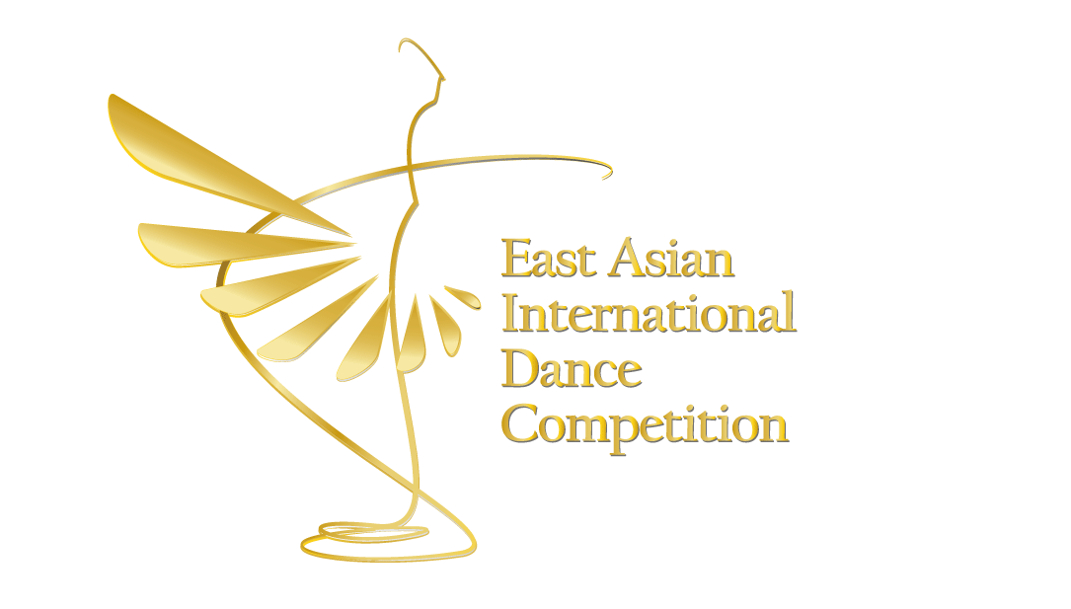

Application date : Y M D
Program │ Contemporary

- Solo
※ If the title of the work is Korean, fill in the English name. (English can be omitted.)
 | Solo
Title
Composer
Choreographer
Time
Start Position | □ Left side □ Right side
Stage props | □ O □ X
Music | □ Position □ Music

- Duet / Group
※ If the title of the work is Korean, fill in the English name. (English can be omitted.)
 | Duet
Title
Composer
Choreographer
Time
Start Position | □ Left side □ Right side
Stage props | □ O □ X
Music | □ Position □ Music

Application date : Y M D

Program │ Practical Dance

- Solo
※ If the title of the work is Korean, fill in the English name. (English can be omitted.)
 | Solo
Title
Composer
Choreographer
Time
Start Position | □ Left side □ Right side
Stage props | □ O □ X
Music | □ Position □ Music

- Duet / Group
※ If the title of the work is Korean, fill in the English name. (English can be omitted.)
 | Duet
Title
Composer
Choreographer
Time
Start Position | □ Left side □ Right side
Stage props | □ O □ X
Music | □ Position □ Music

Application date : Y M D
<Providing personal information and consent to use >
1. Collection of personal information
- When you apply for 'Eidc', you can use it to check your identity

2. Personal Information Collection Items
- Collected items: name, resident registration number, address, contact, education, qualification, etc.
- Unique Identification Information: Resident Registration Number

3. Retention and use period of personal information
- From the reception date to the end of the event period

4. Disadvantages of denying consent and denying consent
- You may refuse to accept personal information. However, if the consent is rejected,
Participants can not be judged.
- The personal information required to participate in the event will not be used for any purpose other than the Eidc.
Do you agree to the collection and use of personal information? I agree ( ), I do not agree ( )
Do you agree to process your unique identification (social security number)? I agree ( ), I do not agree ( )
Y M D

Name : (Sign)

